Defining the AI and Evaluator Function - DoWell Research

**Definition**

Evaluator - Human being with a skewed behaviour. One among 16 personalities

A! - Combination of 16 behaviours

**What are utility factors of product or service**

The factors are

1. Core factors –.
2. Enhancing factors –.
3. Dual threshold factors –.
4. Love factors –.
5. Neutral factors –.

**How to select components of each factor**

The components in each factor can be selected based on

1. 16 personality model in Psychology,
2. 5 Ws & 5Ys of Market research,
3. 6 thinking hats model of decision support systems.
4. 5 human channel of information

* Bias 1 - Dunning Kruger effect
* Bias 2 - IKEA effect
* Bias 3 - Confirmation Bias
* 5Ws - Who, What, Where, When, Why in relation to environment
* Human factor - Carelessness, EQ….. of evaluator
* Channel of information - See, Hear, Taste, Feel, Smell belongs evaluator / AI

**Defining the Function of Observation**

Absolute Observation of a object = Evaluator’s observation of a object - Error

FA.Object = FE.Object - FE.Personality - FE.Error

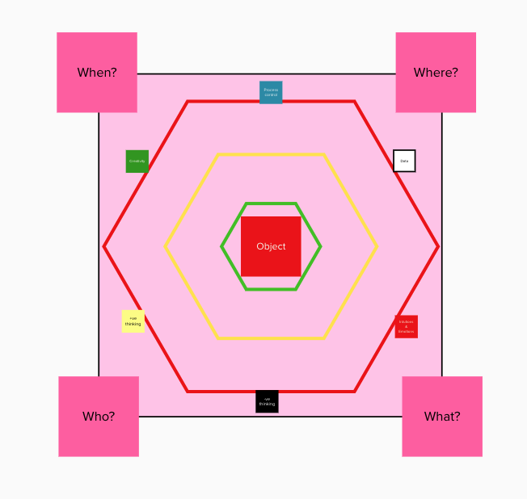

**Defining function of Evaluator Personality** [FE.Personality]

FE.Personality = ∑i=1n[PersonalityVi] - (v = variables in 16 personality model)

**Defining function of Evaluator Error** [FE.Error]

FE.Error = ∑i=13[Biasi] + ∑i=0∞[Human factor]

**Definition of Object of Evaluator**

FE.Object = ∑i=15[FE.Object.Channel i]

**Defining function of Evaluator Object channel** [FE.Object channel]

FE.Object channel = Who [∑i=1n[Why +∑i=13[Bias]]] + What [∑i=1n[Why +∑i=13[Bias]]] + Where [∑i=1n[Why +∑i=13[Bias]]] + When [∑i=1n[Why +∑i=13[Bias]]] + Error [∑i=1n[Human factor]] ...............{A}

**Transformation {A} to {B}**

FE.Object channel = ∑[Data] + ∑[Emotion] + ∑[Positive thinking] + ∑[Negative thinking] + ∑[Creativity] + ∑[Process] + ∑[E.Bias1] + ∑[E.Bias2] + ∑[E.Bias3] + ∑[E.human error] ...............{B}

Note - Remove Bias and human errors to get Evaluator’s object channel

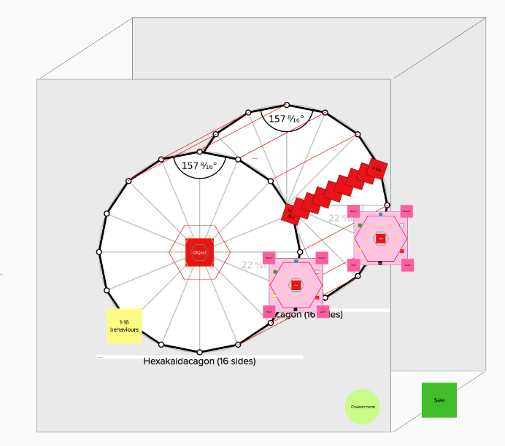

**Definition of one Evaluator channel**

FE.Object.channel = FA.Object.channel + FE.Personality + FE.Error

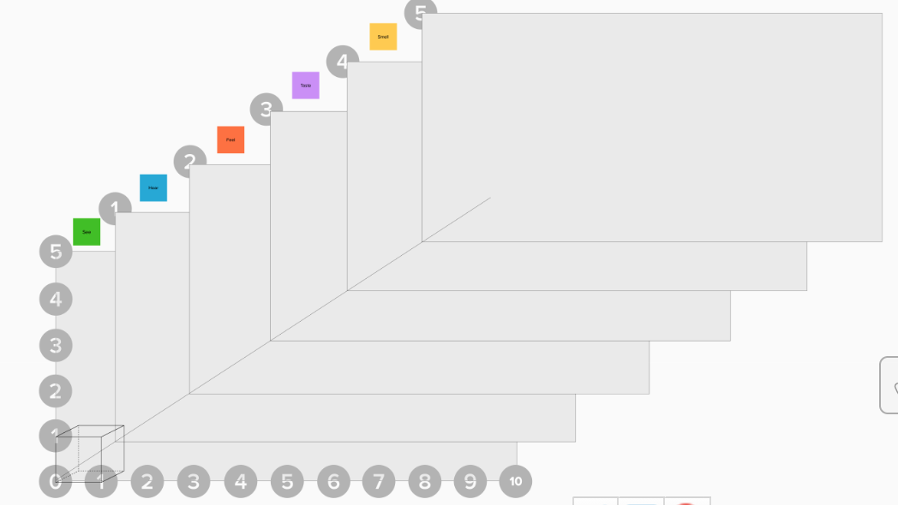

**Definition of Object of Evaluator**

FE.Object = ∑i=15[FE.Object.Channel i]

**Definition of Observation of Evaluator in a context**

FE.Context = ∑i=1∞[FE.Object] + EE.ID + EE.Latitude, E.Longitude + EE.Regional time + DDowell.Timer + EE.incremental knowledge

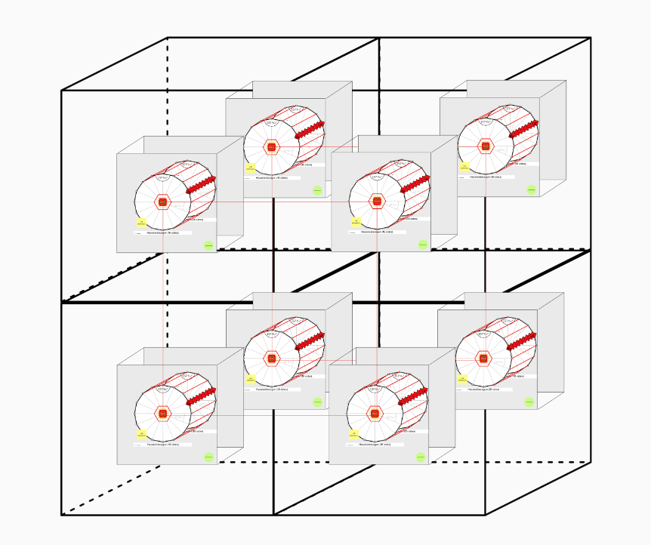

**Transformation of Context of Evaluator to AI**

Object E.definition = ∑[Object E.Absolute.Object] =

∑i=116[FE.Object] - [∑i=116[EE.personality +∑i=0∞[Evaluator]]]

Object AI.definition = ∑[Object AI.Absolute.Object] = ∑i=116[FE.Absolute Object.Perspective i]

**Definition of Observation of AI in a context**

FAI.Context = ∑i=1∞[FAI.Absolute Object] + EE.ID + EE.Latitude, E.Longitude + EE.Regional time + DDowell.Timer + AIAI.incremental knowledge

**Definition of AI in a learning**

FAI.Context = FE.Context + FAI.Learning

**Definition of Contextual observation in time series in a Video evaluation**

∑i=0t[FE.Context i] = ∑i=0t[FAI.Context i]

**Design blueprint**

**5 Factor design**

**Quality process**

Control charts and Statistical Experiments

**Scenario analysis using Pareto distribution**

Design version 1